Assignment Submission Report

Name: Nico Natividad
Course: intermediate python and flask
Cohort:68
Assignment: final report

GitHub Repository Link: Nico-Natividad/111--BACKEND

Evidence of Functionality - Frontend/UI
Attach 3 screenshots only (examples):
- Main screen
- One interaction working
- One validation / error state
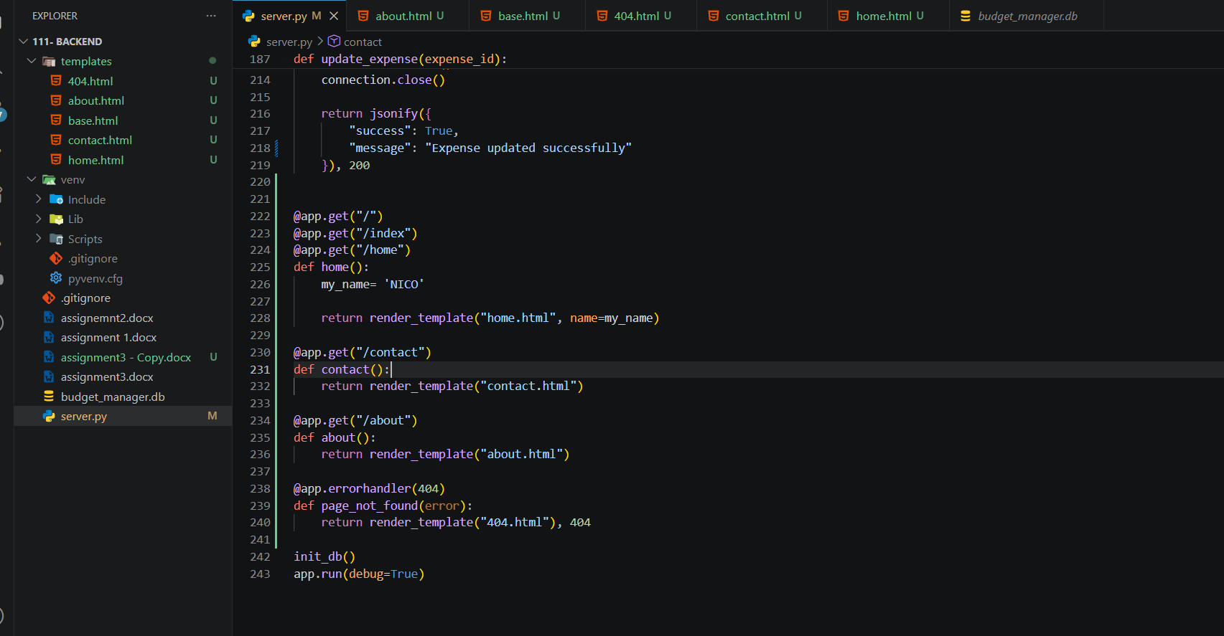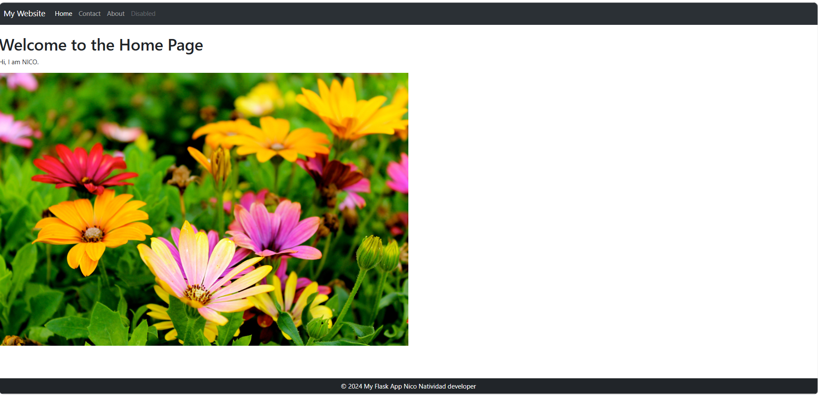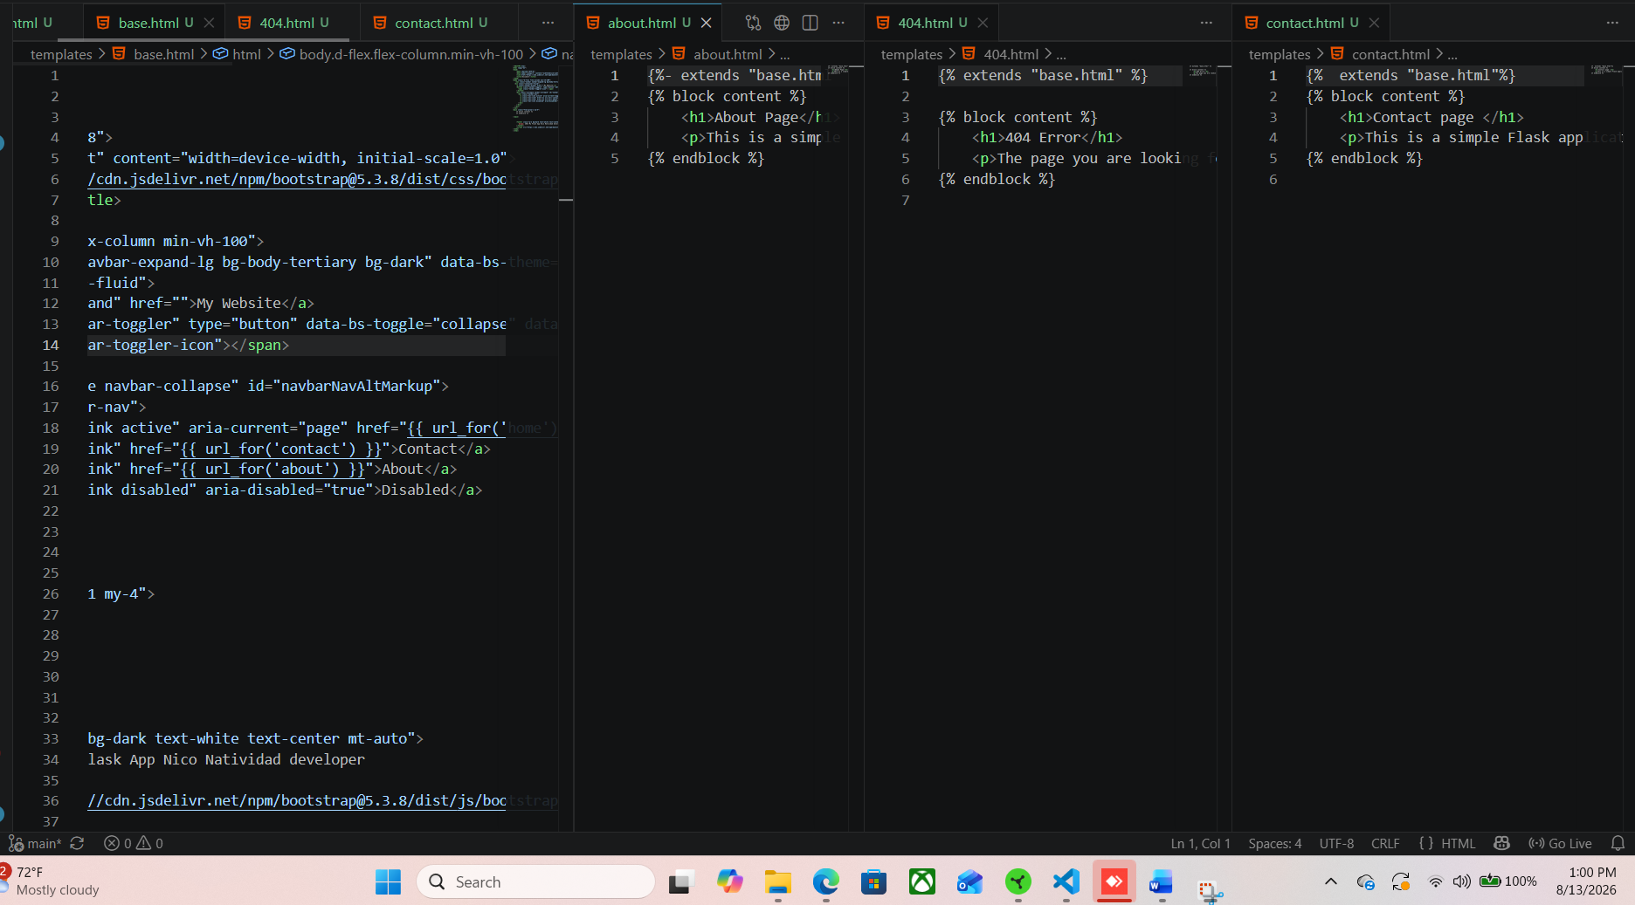

AI Disclosure (Required) – Highlight the one that applies
- I did not use AI
- I used AI for help
- AI generated parts of my code

